Joel Edwards
Course: Java Programming 1
Homework 7
April 15, 2011

Source:

WindChill.java:
import java.applet.Applet;
import java.awt.Button;
import java.awt.Checkbox;
import java.awt.CheckboxGroup;
import java.awt.Color;
import java.awt.event.AdjustmentListener;
import java.awt.event.AdjustmentEvent;
import java.awt.event.ItemListener;
import java.awt.event.ItemEvent;
import java.awt.Font;
import java.awt.GridLayout;
import java.awt.Label;
import java.awt.Panel;
import java.awt.Scrollbar;

public class WindChill
extends Applet
implements AdjustmentListener, ItemListener
{
public static final long serialVersionUID = 1L;

private Scrollbar speedSlider = new Scrollbar(Scrollbar.HORIZONTAL, 10, 10, 5, 60);
private Label speedLabel = new Label();
private CheckboxGroup groupSpeed = new CheckboxGroup();
private Checkbox radioSpeedM = new Checkbox("MPH (Miles per Hour)", groupSpeed, true);
private Checkbox radioSpeedK = new Checkbox("KPH (Kilometers per Hour)", groupSpeed, false);

private Scrollbar tempSlider = new Scrollbar(Scrollbar.HORIZONTAL, 32, 30, -50, 120);
private Label tempLabel = new Label();
private CheckboxGroup groupTemp = new CheckboxGroup();
private Checkbox radioTempF = new Checkbox("°F (Farenheit)", groupTemp, true);
private Checkbox radioTempC = new Checkbox("°C (Celcius)", groupTemp, false);

private Label indexLabel = new Label("");

public void init() {
setLayout(new GridLayout(3,1));
Font font = getFont();
setFont(font.deriveFont(Font.BOLD));

Panel speedPanel = new Panel(new GridLayout(4,1));
speedPanel.add(speedSlider);
speedPanel.add(speedLabel);
speedPanel.add(radioSpeedM);
speedPanel.add(radioSpeedK);
speedPanel.setBackground(color(0.8, 0.8, 1.0));
add(speedPanel);

Panel tempPanel = new Panel(new GridLayout(4,1));
tempPanel.add(tempSlider);
tempPanel.add(tempLabel);
tempPanel.add(radioTempF);
tempPanel.add(radioTempC);
tempPanel.setBackground(color(1.0, 0.5999999, 0.0));
add(tempPanel);

Panel displayPanel = new Panel(new GridLayout(1,1));
displayPanel.add(indexLabel);
displayPanel.setBackground(color(0.8, 1.0, 0.4));

add(displayPanel);

// Configure widgets
speedSlider.addAdjustmentListener(this);
tempSlider.addAdjustmentListener(this);

radioSpeedM.addItemListener(this);
radioSpeedK.addItemListener(this);
radioTempF.addItemListener(this);
radioTempC.addItemListener(this);

// Calculater initial index
reportWindSpeed();
reportTemperature();
updateIndex();
}

private Color color(double r, double g, double b) {
return new Color((float)r, (float)g, (float)b);
}

private void updateIndex() {
double windSpeed = speedSlider.getValue();
double temperature = tempSlider.getValue();
double x = 0.303439 * Math.sqrt(windSpeed) - 0.0202886 * windSpeed;
double index = 91.9 - (91.4 - temperature) * (x + 0.474266);

index = radioTempF.getState() ? index : (index - 32) * (5.0/9.0);

indexLabel.setText("Windchill Index: " +(int)index);
}

private void reportWindSpeed() {
int windSpeed = speedSlider.getValue();
String units = "MPH";
if (radioSpeedK.getState()) {
units = "KPH";
windSpeed *= 1.609344;
}
speedLabel.setText("Wind Speed: " +windSpeed+ " " +units);
}

private void reportTemperature() {
int temperature = tempSlider.getValue();
String units = "°F";
if (radioTempC.getState()) {
temperature = (int)((temperature - 32) * (5.0 / 9.0));
units = "°C";
}
tempLabel.setText("Temperature: " +temperature+ " " +units);
}

public void itemStateChanged(ItemEvent evt) {
Object source = evt.getSource();
if ((source == radioSpeedM) || (source == radioSpeedK)) {
reportWindSpeed();
updateIndex();
} else if ((source == radioTempF) || (source == radioTempC)) {
reportTemperature();
updateIndex();
}
}

public void adjustmentValueChanged(AdjustmentEvent evt) {
Object source = evt.getSource();
if (source == speedSlider) {
reportWindSpeed();
updateIndex();
} else if (source == tempSlider) {
reportTemperature();
updateIndex();
}
}
}

WindChill.html:
<html>
<head>
<title>Wind Chill Index</title>
<meta http-equiv="pragma" content="no-cache" />
</head>
<body>
<applet code="WindChill.class" width="300" height="325">
</applet>
</body>
</html>

Test Output:
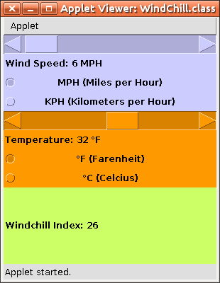
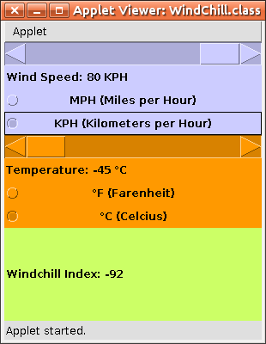

Webpage:
http://scaglietti.dyndns.org/WindChill/
